Liveware
Abra ⬅➔ ADP Interface
Usage Guide

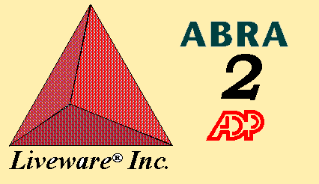

Copyright 1999 - 2002 , Liveware, Inc.
Introduction
Abra’s HR Module is a powerful and flexible tool for managing employee data. ADP produces a robust, payroll system that is used by thousands of companies. Because they both deal with the same item (employees), there is a great deal of overlap between them in terms of data capture and storage. For instance, both systems track employee name and address. Over the years a philosophy of “single-point data entry” has arisen which states simply that a data element should be entered once and only once and populate all other systems that require it.

While straightforward in concept, this philosophy is somewhat tougher to execute well. There are a number of reasons for this including the fact that data capture rules vary depending on system, data elements do not exactly match between systems (in type, length or translation) and there are no transport mechanisms between systems.

Liveware has addressed this with its Abra2ADP interface program. It is an easy-to-use program that takes the basic employee master data stored in either system and formats it for the other to create a base record. This lets the company determine the best place to gather the initial employee information and the various administrators concentrate on handling those aspects of their systems that are most important. The Abra into ADP functionality works only with ADP PC/Payroll for Windows and Abra for Windows or AbraSuite. DOS products from either company have major structural differences and will not work with this program. The ADP into Abra functionality works with either ADP Windows or DOS but only DOS version 6 or higher.

The interface is flexible, allowing a high degree of variability in translating data from Abra to ADP. This includes support for asymmetric company definitions, code table disparities, different field lengths & definitions and internal rules for data entry. Much of this is handled by system parameter tables that can be edited by those using the program. There are some situations and areas, however, where the program itself will need modifications by an experienced consultant.

Abra offers a product called simply “AbraLink” which allows one to extract data from the system and prep it for load to ADP. This program is fine for simple single-company extracts. It breaks down for more complex actions. It also is not date-based. Liveware’s Abra2ADP interface is unique in that it reads the internal system audit file (SYAUDIT.DBF) to determine what changed for employee records in a given date range. Thus, only the data that actually was modified is sent using the interface and only if it was changed during the requested period.

This guide provides and overview of the functionality and usage requirements of the Abra2ADP program. It will go into some detail regarding editing the parameters, however, some areas should only be maintained after discussion with a Liveware consultant.

Starting the Program
Typically, the person using the Abra2ADP interface program will have a shortcut saved on the PC desktop or in a folder of special applications for Abra. Generally speaking, Liveware will place the program and associated files in a directory called OTHERPRGS (alternatively OTHRPRGS or OTHERPROGS depending on the operating system) located just below the PROGRAMS directory of Abra. An example would be:
R:\Abra Suite\Programs\OtherPrgs\Abra2ADP.EXE.

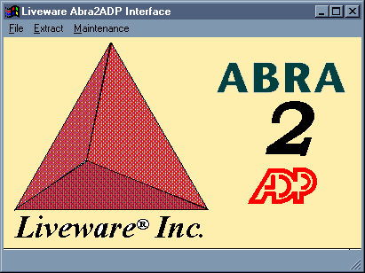
Double-clicking the shortcut icon or typing the local equivalent of the command indicated above will start the program and display the initial screen:

All functions of the program are executed from here. This screen lets you kickoff your ADP extracts, maintain the parameter tables within the program and view the extracts upon completion. Each of the three menu items will be addressed in detail. Menu items are selected by using the mouse or pressing [ALT]+[the underlined letter in the menu item].

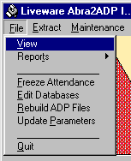
File
Selecting this menu item will display a menu with the choices shown at right:

…View
Selecting “View” calls up an Open File dialog box that allows you to select a file created via the interface and review its contents and structure from NotePad (a plain text file editing/viewing program in Windows). By default the interface places all files for load into ADP into the ADPDataExport folder. All the files shown will have similar names as indicated below:

EMPcccdd.CSV
Or

EPIcccdd.CSV

EMP and EPI identify the file for ADP as being an employee data import or a paydata import (respectively). The CSV at the end of the name means that the file is in a special format called CSV (comma separated values) where all data is surrounded by quotation marks and separated by commas. The section shown as ccc is the three character ADP company code to which the data will be loaded. The section identified as dd is a two character description that helps distinguish the type of data stored within the file. The standard codes used in the Abra2ADP interface are shown in the table below:

Code | Description | Comments
NW | NeW Employee Data | Contains elements of Demographics and Organizational data
DM | DeMographics Data | Contains a person’s name, address and other personal data elements
OR | ORganizational Data | Contains the person’s salary, department and other company related data elements
TM | TerMination Data | Contains the status and effective date of termination for a person no longer with the company (one each for EMP and EPI)
BN | Benefits Data | Contains benefits deductions and 403(b) contribution amounts
AY | Attendance end of Year Data | Updates the beginning of year allowances and zeroes out the taken amounts
AO | Attendance Ongoing Data | Contains adjustments to the total allowance and taken amounts for each pay period

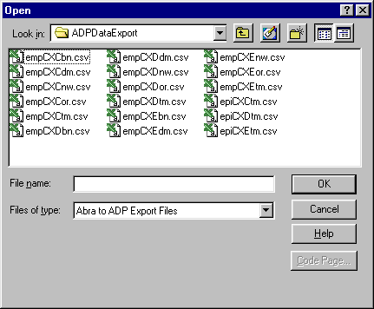
There will be one set of files generated for each combination of dd code and company code. Thus, if your company has three ADP company codes, you should expect 6 x 3 or 18 files to be generated (remember that two TM files are created per company code).

The open dialog looks the same as in other Windows programs. Simply double-click on the file or highlight it and click Open to review the data. If changes have to be made to the data, this is the recommended way to handle this. Opening the files in Excel can cause problems because Excel tries to apply its own logic to the data.

…Reports
To make data review easier, a set of reports have been added that show the data changes set to be made in ADP. Each report corresponds to one of the data types identified in the table above:

New Hire Changes
Demographics Changes
Organizational Changes
Benefit Changes
Termination Changes
AutoPay Cancellations

Each of these reports is generated in R&R Report Writer and can be edited or modified using that program (see appendix). The reports consolidate the changes in a category for all company codes defined.

…Edit Databases
The interface uses a large number of files to control its various functions. This menu option allows a consultant to edit and add to the definitions for using them throughout the program. It means that the effort and expense of reprogramming can be avoided for certain changes.

…Rebuild ADP Files
At times the temporary tables used to hold the employee data for processing to ADP can become corrupted or require changes (due to modifications made by ADP to their headings or by needing different data in a file). Selecting this option will force the system to read through the table definition file and add back the header text. The header text is what appears on the top line of the file when viewed in NotePad and defines the data elements and their order for the information transmitted in the file.

…Update Parameters
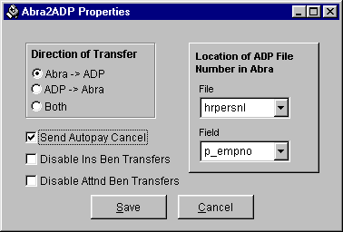
The interface offers a great deal of flexibility in its use. Some configuration of it is possible through a properties screen containing a number of options for the interfaces’ execution. These are described below (changes won’t take effect until the interface is exited and restarted):

Direction of Transfer
The interface can be configured to allow transfers between systems in a single direction or bi-directionally. By default, the interface is setup to allow data to move from Abra into ADP. Changing this option will change the behavior of the Extract menu item.

Send AutoPay Cancel
Selecting this means that the additional file EPIcccTM.CSV will be created for terminations in the system. This file controls whether the AutoPay flag is turned off in ADP. If this is not checked, the Payroll Administrator has to handle this process manually.

Disable Ins Benefits Transfers
For a variety of reasons, some companies don’t want the interface to handle the transfer of benefits deductions between Abra and ADP. For them, clicking this choice makes it impossible to click on the Benefits checkbox on the Data Transfer screen.

Disable Attnd Ben Transfers
Similarly, some companies don’t want the interface to handle the transfer of attendance balances and time taken amounts. Clicking this choice prevents someone from accidentally selecting the Attendance checkbox / pulldown from the Data Transfer screen.

Location of ADP File Number in Abra
Often, the employee number used in Abra will be made to match the file number in ADP. However, this is not always the case. To provide flexibility, the system allows companies to determine exactly where the ADP file number is stored for every employee.

Clicking on “Save” will make the changes take effect at the next startup of the interface.

…Quit
Selecting this option exits the program (you can also click the “x” in the upper-right-hand corner of the screen).

Extract
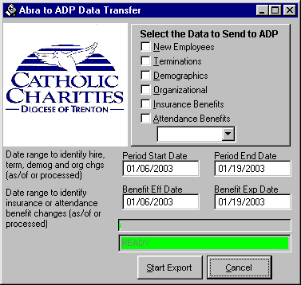
There are two directions that data can move. From Abra into ADP and from ADP into Abra. Depending on the selection made on the Parameters screen, the extract menu allows you to select the option that is right for a given company’s circumstances. Both selections will be dealt with in this se ction.

…Abra to ADP
This menu item brings up the main program window that controls the Abra to ADP Data Transfer. It allows the person using the program to specify the date range for which the extract should take place (i.e. identifying hiring and firing actions, salary and other date-based changes in the system). This should generally correspond to the payroll period for which the extract will be loaded. This helps to ensure that the data pulled from Abra will be synchronized with the data for the current pay period. Extract types which are not enabled are “grayed-out” so that they cannot be selected.

The screen shown also allows the person using the system to select the type of data files to produce for ADP. These correspond to the file types identified in the table above. Note that regardless of the buttons clicked, the interface program will produce a file for each company code and extract type. Those not clicked will be empty, including a header record only.

Those selected may or may not contain data depending on whether there were changes made to a company’s corresponding employees in the selected data range. Files with no data will also have a header record only. Building one of each type of file is a quality control check which ensures that no files are missing and that no old data (which could inadvertantly undo another change) is accidentally forwarded and loaded to ADP.

The dates shown on the screen are the dates between which changes will be identified (inclusive). The program “remembers” its previous date ranges so the operator can be certain that no periods overlap.

To execute the program, click on the “Start Export” button at the bottom. When complete, a window will appear indicating that the process is complete. Click “OK” on that window. To close the main screen, click on the small close box at the upper right of the transfer control screen.

…ADP to Abra
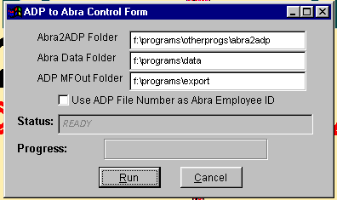
This menu option takes a standard ADP extract file (called a Master File Output data extract) for each company code and formats it for update to the Abra system. Each file is identified by the name MFOUT.ccc where ccc represents the individual ADP company code whose data is stored in the file. This file is created by Payroll using a special utility which ADP provides for the purpose of creating this (older) file layout. The data can represent either a full refresh of the ADP system’s data into Abra or the changes only. Generally, your Payroll Administrator will provide an initial data upload for setting up Abra and then only changes on an ongoing basis.

Making the selection will display a screen as shown. There are three entry items and one checkbox here. The entry fields control the location of the various files necessary to transfer the data between the two systems. The checkbox defines where the ADP file number will map to in Abra. The buttons provide the execution options: Run the update or Cancel (close) it. Choosing run starts the process:

- System looks for each MFOUT.ccc file stored in the location specified by “ADP MFOut Folder.” It loads the raw information into a database for processing. If a file is not found, that company is skipped. Note that data files should be deleted by the person running the system after each update to avoid accidentally uploading the same data twice.
- Each record in the raw data file is analyzed and broken up into its component pieces (i.e. one line might have Name, Status and SSNo and this has to be turned into up to five data items…Last Name, First Name, Middle Initial, Status and SSNo). The system uses a file stored on the network to determine where each data item is in the raw data file, whether it should be imported and if special processing is needed (i.e. to convert an all-uppercase address or city to mixed capitals).
- For each person, the data extracted is stored in a “transit file.” This is a temporary holding bin for the ADP data that resembles the standard Abra file layout. The transit file will be compared against the live Abra data file to identify changes or updates required.
- Each data item in the transit file is compared to its corresponding one in the live Abra file. Where there are differences, the program will update Abra and generate a record of the change in the audit trail and build history records where applicable (i.e. if a salary change occurs). At this time, for new employees, the program will refer to a file of default values to use in fully building the Abra record. The location of these data files is indicated by the “Abra Data Folder” entry.
- Throughout the process, the Status field on the screen will change to reflect what is being worked on. At the same time, the Progress bar will march towards 100% completion (in three steps). Upon completion of the process, a “Processing Complete” message will appear in the Status field. Click Cancel at this time to close the screen.

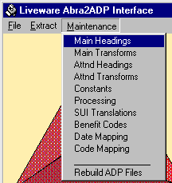

Maintenance
Much of what is required to customize the program is defined in databases delivered with the system. These databases can be modified (items added, deleted or changed) through this menu item. There are nine main parameter files used in the application (Benefit Codes is enabled but empty at Pegasus). Some are used for both transfers, but most are specific to either Abra to ADP or ADP to Abra. Each of the eight implemented tables is described below.

…ADP Headings - Standard & Attendance (Abra to ADP)
These screens let the operator modify the files ADPFLDTR and ADPATTND. They are the translations between Abra’s HRPERSNL fields and the associated data element in the ADP database (as defined in the ADP PC/Payroll for Windows Data Exchange Guide). It also identifies which field in the temporary extract tables gets populated for a particular ADP value. This is the file referenced by the “Rebuild ADP Files” function noted earlier.

All of the maintenance screens (see Appendix X) look similar to these in a few key ways: They all have a grid on the screen that can be scrolled through and the columns resized. Editing can be done directly on the form by clicking in the desired cell and typing. There are three buttons at the bottom of the screen. “Add” creates a blank record and positions the cursor at the last record of the file for editing. “Delete” marks the record line on which the cursor is positioned for deletion. Clicking “Exit” will close the window and purge marked records. Note that additions to fields on this screen will have to be reflected by physical database changes in the temporary files used to store the data being sent to ADP. These database are core elements of the system and changes by a non-consultant are recommended. See the appendix for a list of files and their data structures.

…Constants (Abra to ADP and ADP to Abra)
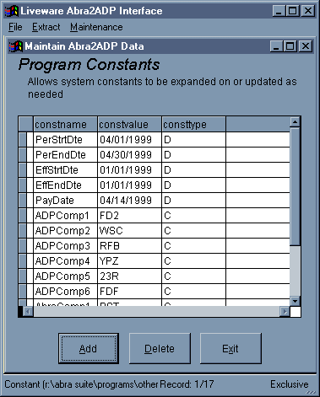
Throughout the interface program are values which do not change at all or often between execution sessions. These are called constants and include such things as the effective dates shown on the Extract screen, the company codes in ADP and Abra, etc. Selecting Constants from the menu lets you directly update these constant values needed by the program. The screen works the same way as noted above.

Note that when dealing with multi-company systems that the last number at the end of the constant name (constname) is significant and must match up one-for-one with an AbraComp and an ADPComp record, duplicating where needed (i.e. if one company from one system maps to two in another). Also, every name shown is significant in its structure. Changing them will cause the system to crash or behave oddly. The file being modified is called CONSTANT.

…Data Mapping (Abra to ADP)
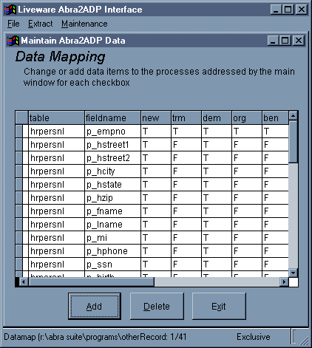
This menu selection allows editing of the DATAMAP file. It is similar to the ADP Header file in that it specifies a number of Abra fields for review. However, DATAMAP is used to define the fields that are scanned for within the audit trail file. Any change to a field shown in DATAMAP will create a record in one of the ADP files. Which file is updated is determined by the T/F value stored under the column named for each of the files (new, org, dem, trm and ben). A value of “T” indicates that a change in that field should be written to the specific file in the column, while a value of “F” indicates that it should be ignored for the particular file. Thus, p_hphone is written to the new and demographics files (new and dem), but not organizational or termination (org or term).

As with the header file, changes to this table must be approached cautiously. This is because fields can easily be removed from the list (simply by deleting or typing “F” in a file’s block). But adding additional records does not automatically work since there may be customized programming/translations needed to properly convert the item over to ADP’s specification.

Also, adding records does not guarantee that the temporary records will have room for the new data elements to go. The structures will most likely need revision.

Finally, some elements shown in this file may change without others changing. For instance, a person might change departments but not locations in Abra. Thus the audit trail would be an incomplete source for data needed by ADP’s Home Department. In nearly all cases, data found in the audit trail is supplemented or completed by data from HRPERSNL.

…SUI Translations (Abra to ADP)
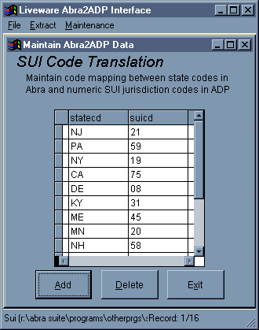
This selection brings up a window into the SUI database. This file is used for maintaining the translation between the standard two character state code and ADP’s internal representation of a state for SUI taxation purposes. Only one code per state is supported by the interface (some states have multiple choices). Only those states that currently have employees working in them are recorded here. These translations come from Appendix C of the ADP PC/Payroll for Windows Data Exchange Guide.

…Benefit Codes
The Abra2ADP interface offers a lot of flexibility in defining how benefits stored in Abra are translated into deduction codes (or earning codes) within ADP.

Entries represent Abra benefit codes and their analogous ADP codes. Note that the system allows the same benefit code to be applied to different ADP deductions. Also, the benefits codes can expire, allowing the system to handle changes in the way that companies track their benefits over time.

The table that this screen controls is called VALIDBEN.
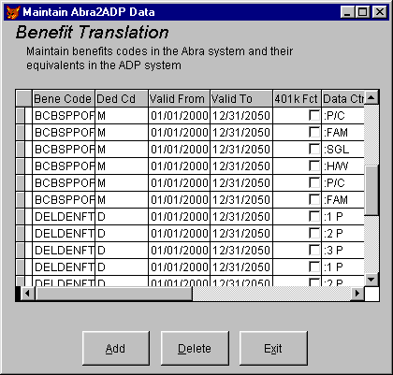
…Code Mapping (Abra to ADP and ADP to Abra)
Within any database system, there are a great deal of values which are stored as predefined codes to ensure consistency. These codes rarely are the same across databases, even for things as straightforward as marital codes or gender codes (for instance, one system treats as numbers, the other letters).

The interface program has to be able to take data from one code table in Abra and translate it to its analog in ADP. This is what the Code Mapping choice allows. These translations are (not surprisingly) stored in the TRANSLATE file.

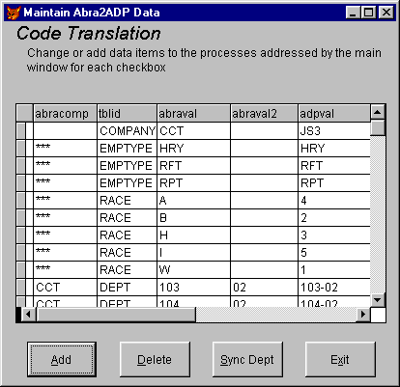
The screen shown below indicates the correlation between two Abra values within a company and their ADP counterpart. The example shown can be read as follows: For company CCT, the ADP department code value 103-02 breaks into two parts. These are department “103” and pay category “02” (these are stored in Abra in P_LEVEL2 and P_LEVEL4 codes).

…ADP Layout (ADP to Abra)
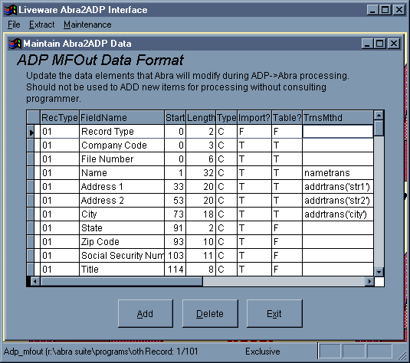
ADP’s master file extract is a comprehensive export of the data stored in the ADP system. However, it is laid out in a relatively complex manner. The specifications for the file are given in the ADP booklet entitled “Masterfile Output Utility Guide.” This book shows the file structures and positions of each data item extracted from the ADP system and its formatting and rules. The ADP Layout table is a database representation of this booklet. The table shows a Record Type (01 through 04 although there are nine total) and Field Name identifying the data element. The position within the MFOUT.ccc file as well as the data type and field length is specified here. This gives some flexibility if ADP should ever change the file layout (highly unlikely).

The next two columns are True/False items used in processing. The first is the indicator for import or not of the data item. Adding elements to the processing (i.e. making them True) requires updating the program itself to identify where the value found should be placed in Abra. The next column indicates whether there is any special processing required on the data element (i.e. taking the Home Department and breaking it into location/department codes in Abra or converting the all-caps single-item Employee Name field and creating a first, middle and last name in mixed case format. This column should NEVER be changed without modifying the program itself. Similarly, the final column should be left alone as well. This is the name of the procedure that must be run for a field requiring table translations.

…Default Values (ADP to Abra)
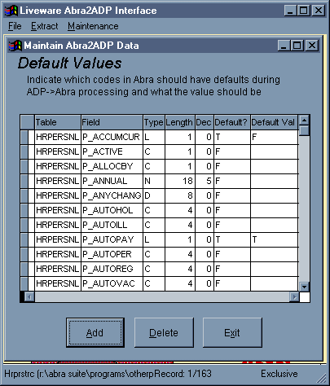
New employee records exported from ADP contain a great deal of information. However, there are many items that are updated behind the scenes in the Abra main file when an employee gets added using Abra’s menus and actions. There are also some “visible” items in Abra’s file that are not provided by ADP’s MFOUT.ccc export (i.e. race and employee category/type). For these items, the Abra2ADP program provides a list of default values that can be maintained so that these background or not-supplied items can be added during processing.

Each item indicated as requiring a default value is shown by a “T” in the “Default?” column. Any default value needed should be entered in the column headed “Default Val.” Note that any field with a default value indicated will override an actual value provided from the file. For instance if you set P_LNAME to default to “Jones” then all employees would be given Jones as their last name, not just those where it was not known. Use defaults carefully.

…Emp Num Translate (ADP to Abra)
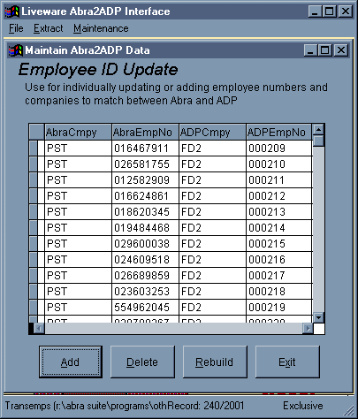
Each employee in ADP is identified by a combination of their Company Code and their File Number. Similarly, each employee in Abra is uniquely identified by their Company Code and Employee Number. Abra has been setup at Pegasus to use 9-digit employee numbers (the Social Security Number without dashes). The ADP company is stored in Abra under P_LEVEL3 and the ADP File Number is stored under P_MISC1. ADP allows the same employee to exist more than once per company as long as they have different file numbers. In order to identify whether the employee record has been loaded in Abra, a translation table between employees for Abra and ADP must be maintained. This screen is shown at right. This screen can be kept up-to-date either manually or en masse. Manual updating is handled as with the other table maintenance items.

Mass updating is done using the “Rebuild” button on the screen. This should be done prior to updating each week. When clicked, the employee translation table is wiped clean and then refreshed with the most current translations stored in Abra in the P_EMPNO, P_COMPANY, P_MISC1 and P_LEVEL3 fields. This table lets the ADP upload process determine if the employee already exists in Abra and thus how to handle the record.

Appendix

Temporary Databases used to Capture ADP Data

Database File Name | Creates ADP Upload File | Comments
NEW.DBF | EMPcccNW.CSV | New Employees
DEM.DBF | EMPcccDM.CSV | Demographics Information
ORG.DBF | EMPcccOR.CSV | Organizational Information
TRM.DBF | EMPcccTM.CSV | Terminated Employees
EXT.DBF | EPIcccTM.CSV | Autopay Cancellation
OGO.DBF | EMPcccAO.CSV | Ongoing Attendance Information
NYR.DBF | EMPcccAY.CSV | New Year Attendance Information

Appendix

Temporary Database Structures
NEW.DBF
Structure for table: R:\ABRASU~1\PROGRAMS\OTHERPRGS\NEW.DBF
Number of data records: 5
Date of last update: 04/12/1999 Code Page: 1252
Field | Field Name | Type | Width | Index
1 | FLD01 | Character | 30 | No
2 | FLD02 | Character | 30 | No
3 | FLD03 | Character | 30 | No
4 | FLD04 | Character | 30 | No
5 | FLD05 | Character | 30 | No
6 | FLD06 | Character | 30 | No
7 | FLD07 | Character | 30 | No
8 | FLD08 | Character | 30 | No
9 | FLD09 | Character | 30 | No
10 | FLD10 | Character | 30 | No
11 | FLD11 | Character | 30 | No
12 | FLD12 | Character | 30 | No
13 | FLD13 | Character | 30 | No
14 | FLD15 | Character | 30 | No
15 | FLD16 | Character | 30 | No
16 | FLD17 | Character | 30 | No
17 | FLD18 | Character | 30 | No
18 | FLD19 | Character | 30 | No
19 | FLD20 | Character | 30 | No
20 | FLD21 | Character | 30 | No
21 | FLD22 | Character | 30 | No
22 | FLD23 | Character | 30 | No
23 | FLD24 | Character | 30 | No
24 | FLD25 | Character | 30 | No
25 | FLD26 | Character | 30 | No
26 | FLD27 | Character | 30 | No
27 | FLD28 | Character | 30 | No
28 | FLD29 | Character | 30 | No
29 | FLD30 | Character | 30 | No
30 | RECTYP | Character | 1 | No
** Total ** 872

Number of data records: 5
Date of last update: 04/12/1999 Code Page: 1252
Field | Field Name | Type | Width | Index
1 | FLD01 | Character | 30 | No
2 | FLD02 | Character | 30 | No
3 | FLD03 | Character | 30 | No
4 | FLD04 | Character | 30 | No
5 | FLD05 | Character | 30 | No
6 | FLD06 | Character | 30 | No
7 | FLD07 | Character | 30 | No
8 | FLD08 | Character | 30 | No
9 | FLD09 | Character | 30 | No
10 | FLD10 | Character | 30 | No
11 | FLD11 | Character | 30 | No
12 | FLD12 | Character | 30 | No
13 | FLD13 | Character | 30 | No
14 | FLD15 | Character | 30 | No
15 | FLD16 | Character | 30 | No
16 | FLD17 | Character | 30 | No
17 | FLD18 | Character | 30 | No
18 | FLD19 | Character | 30 | No
19 | FLD20 | Character | 30 | No
20 | FLD21 | Character | 30 | No
21 | FLD22 | Character | 30 | No
22 | FLD23 | Character | 30 | No
23 | FLD24 | Character | 30 | No
24 | FLD25 | Character | 30 | No
25 | FLD26 | Character | 30 | No
26 | FLD27 | Character | 30 | No
27 | FLD28 | Character | 30 | No
28 | FLD29 | Character | 30 | No
29 | FLD30 | Character | 30 | No
30 | RECTYP | Character | 1 | No
** Total ** 872

DEM.DBF
Structure for table: R:\ABRASU~1\PROGRAMS\OTHERPRGS\DEM.DBF

Number of data records: 12
Date of last update: 04/12/1999 Code Page: 1252
Field | Field Name | Type | Width | Index
1 | FLD01 | Character | 30 | No
2 | FLD02 | Character | 30 | No
3 | FLD03 | Character | 30 | No
4 | FLD04 | Character | 30 | No
5 | FLD05 | Character | 30 | No
6 | FLD06 | Character | 30 | No
7 | FLD07 | Character | 30 | No
8 | FLD08 | Character | 30 | No
9 | FLD09 | Character | 30 | No
10 | FLD10 | Character | 30 | No
11 | FLD11 | Character | 30 | No
12 | FLD12 | Character | 30 | No
13 | FLD13 | Character | 30 | No
14 | FLD15 | Character | 30 | No
15 | FLD16 | Character | 30 | No
16 | FLD17 | Character | 30 | No
17 | RECTYP | Character | 1 | No
** Total ** 482
Appendix

Temporary Database Structures

ORG.DBF
Structure for table: R:\ABRASU~1\PROGRAMS\OTHERPRGS\ORG.DBF
Number of data records: 1
Date of last update: 04/12/1999 Code Page: 1252
Field | Field Name | Type | Width | Index
1 | FLD01 | Character | 30 | No
2 | FLD02 | Character | 30 | No
3 | FLD03 | Character | 30 | No
4 | FLD04 | Character | 30 | No
5 | FLD05 | Character | 30 | No
6 | FLD06 | Character | 30 | No
7 | FLD07 | Character | 30 | No
8 | FLD08 | Character | 30 | No
9 | FLD09 | Character | 30 | No
10 | FLD10 | Character | 30 | No
11 | FLD11 | Character | 30 | No
12 | FLD12 | Character | 30 | No
13 | FLD13 | Character | 30 | No
14 | RECTYP | Character | 1 | No
** Total ** 392

Appendix

Temporary Database Structures

TRM.DBF
Structure for table: R:\ABRASU~1\PROGRAMS\OTHERPRGS\TRM.DBF
Number of data records: 1
Date of last update: 04/12/1999 Code Page: 1252
Field | Field Name | Type | Width | Index
1 | FLD01 | Character | 30 | No
2 | FLD02 | Character | 30 | No
3 | FLD03 | Character | 30 | No
4 | FLD04 | Character | 30 | No
5 | RECTYP | Character | 1 | No
** Total ** 122

Appendix 3 – Customization Tables
Introduction

All of the maintenance screens look similar to each other in a few key ways: They all have a grid on the screen that can be scrolled through and the columns resized. Editing can be done directly on the form by clicking in the desired cell and typing. There are three buttons at the bottom of the screen:

“Add” creates a blank record and positions the cursor at the last record of the file for editing.
“Delete” marks the record line on which the cursor is positioned for deletion.
“Exit” will close the window and purge marked records.

Note that additions to fields on some of these screens will have to be accompanied by physical database changes in the temporary files used to store the data being sent to ADP or in the program code embedded within the system. These databases are core elements of the system and changes by a non-consultant are not recommended. See Appendix Y for a list of files and their data structures.

Appendix X – Database Usage

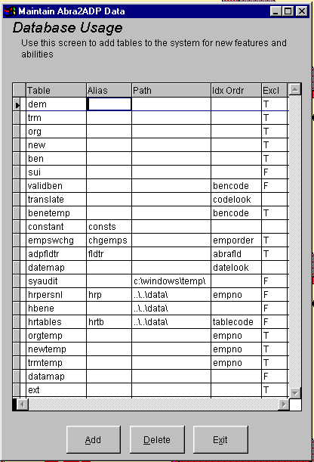

Table: identifies the name of the dbf file needed by the interface
Alias: a shortened name (in some circumstances) that the interface will use instead of the actual name
Path: different files are stored in different places. This column allows them to be defined so that the interface can find them regardless of their location (i.e. sometimes things are moved around as upgrades are made).
Idx Ordr: identifies the pre-defined sort order for a file that makes it easier for the interface to locate a specific piece of information within the file
Excl: determines whether the file will be used by the interface in an “Exclusive” (T for True) or “Shared” mode (F for False). Certain cleanup functions performed by the interface require Exclusive access.
Appendix X – ADP Headings Standard & Attendance

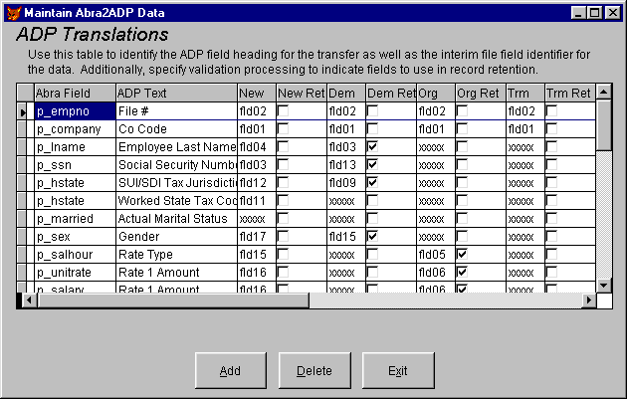

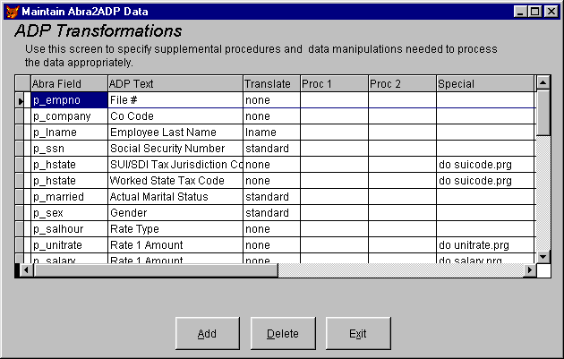

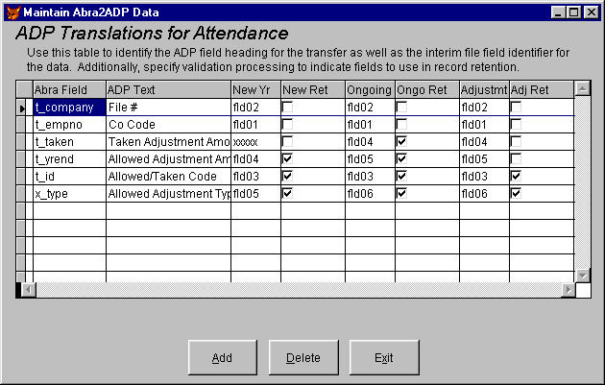

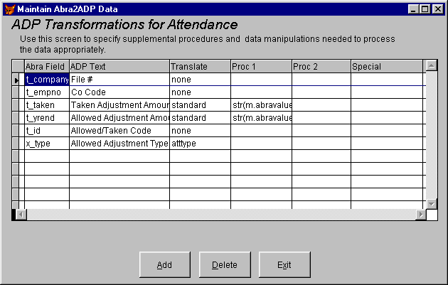
How Do I…

…Prepare for new year attendance balances?

…Update Abra with revised department codes?

…

